CURRICULUM VITAE

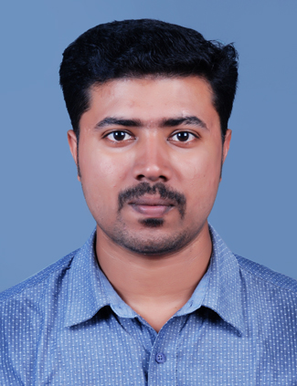
CHINTU VARGHESE ANAND
SABENA
PERINGALA P.O
KAYAMKULAM
ALLEPPEY DIST
KERALA-690559

Phone : +91-8137880532 Email:chintuvarghese1988@gmail.com

Objective: Looking for a challenging career in a reputed organization, to update and sharpen my skills simultaneously making maximum contribution to any firm to which I would be associated.

PROFESSIONAL EXPERIENCE

Name of the Organization : Dintis Technologies Pvt. Ltd.
Designation : ASP.NET Developer
Location : Cochin
Tenure : September 2015 to Present

Duties & Responsibilities:

- Developed solutions in diverse programming scenarios in c#.
- Reporting and presenting user reports for analysis.
- Worked in 3-Tier projects.
- Responsible for Database Integration.
- Client site updates and modifications if any.
- Responsible in GUI development.

Name of the Organization : Nafal Emirates Oil & Gas Services L.L.C
Designation : QC Engineer, Shah Gas Power Plant
Location : Hameem, Adudhabi, UAE
Tenure : Since November 2013 to March 2015

Responsibilities:

- RFI and Certification of work.
- Inspection at site with Client.
- Regular visit to work site and Coordination with site staff.
- Client meeting and status report.

Name of the Organization : Nafal Contracting & Trading Co. LLC.
Designation : Site Engineer, Sohar Independent Power Plant
Location : Sohar, Sultanate Of Oman
Tenure : Since January 2012 to August 2013

Responsibilities:

- To Schedule and execute work in site without delay and reporting to client on daily report basis.
- Daily report submission to client management and company.
- Monthly certification and billing of completed work based on the scope of work.
- Coordination with client for their requirement and execution of work.

Name of the Organization : NedSoft Technologies Pvt. Ltd
Designation : DotNet Programmer
Location : Adoor,Kerala
Tenure : Since August 2010 to November 2011

Responsibilities:

- Training based on .Net application.
- Solution developer for hospitality management and tourism management

CERTIFICATION

- EDGE – SYSTEM INTEGRATION: DOTNET – iON TCS, KOCHI

.NET TECHNICAL SKILLS

- .NET Framework 4.5, ASP .NET, C# .Net, LINQ, .NET CLASS Libraries

ACADEMICS
Qualification | University/Board | Year of Passing | Percentage
B.E Computer Science Engineering | Anna University | 2010 | 64%
12th | CBSE | 2006 | 60%
10th | CBSE | 2004 | 67%

COMPUTER KNOWLEDGE

- Operating System : Windows 7/8/10
- Tools :Photoshop, MS Office, MS Visual Studio 2010/2012
- Languages : C, C# .NET,ASP.NET
- Database :MS SQL Server 2008/2012/2014, ORACLE

PERSONAL DETAILS

- Date of Birth : 11/08/1988
- Sex : Male
- Marital status : Single
- Religion : Christian
- Nationality : Indian
- Passport No : F9658479
- Expiry Date : 03/10/2016
- Languages Known : English, Hindi, Tamil and Malayalam.
- Driving License : Four Wheeler(Light Vehicle) and Two Wheeler
- Permanent Address : Chintu Varghese Anand
Sabena
Peringala P.O
Kayamkulam
Allepey Dist, Kerala, 690559

Declaration:
I hereby declare that all statements made in this application are true complete & correct to the best of my knowledge and life.

Place: Kayamkulam, Alleppey CHINTU VARGHESE ANAND

Date: 19/02/2015

